**5. Write an algorithm and program to sort n numbers using Insertion sort technique.**

**i) Using arrays**

**ii) Using recursion**

**(i)Using arrays:-**

#include<stdio.h>

main()

{

int a[20],n,i,j,k;

printf("\n enter no. of elements=");

scanf("%d",&n);

for(i=0;i<n;i++)

{

scanf("%d",&a[i]);

}

for(i=1;i<n;i++)

{

k=a[i];

j=i-1;

while(j>=0 && a[j]>k)

{

a[j+1]=a[j];

j=j-1;

}

a[j+1]=k;

}

printf("\n sorted array=\n");

for(i=0;i<n;i++)

{

printf("%d\t",a[i]);

}}

**Output:-**

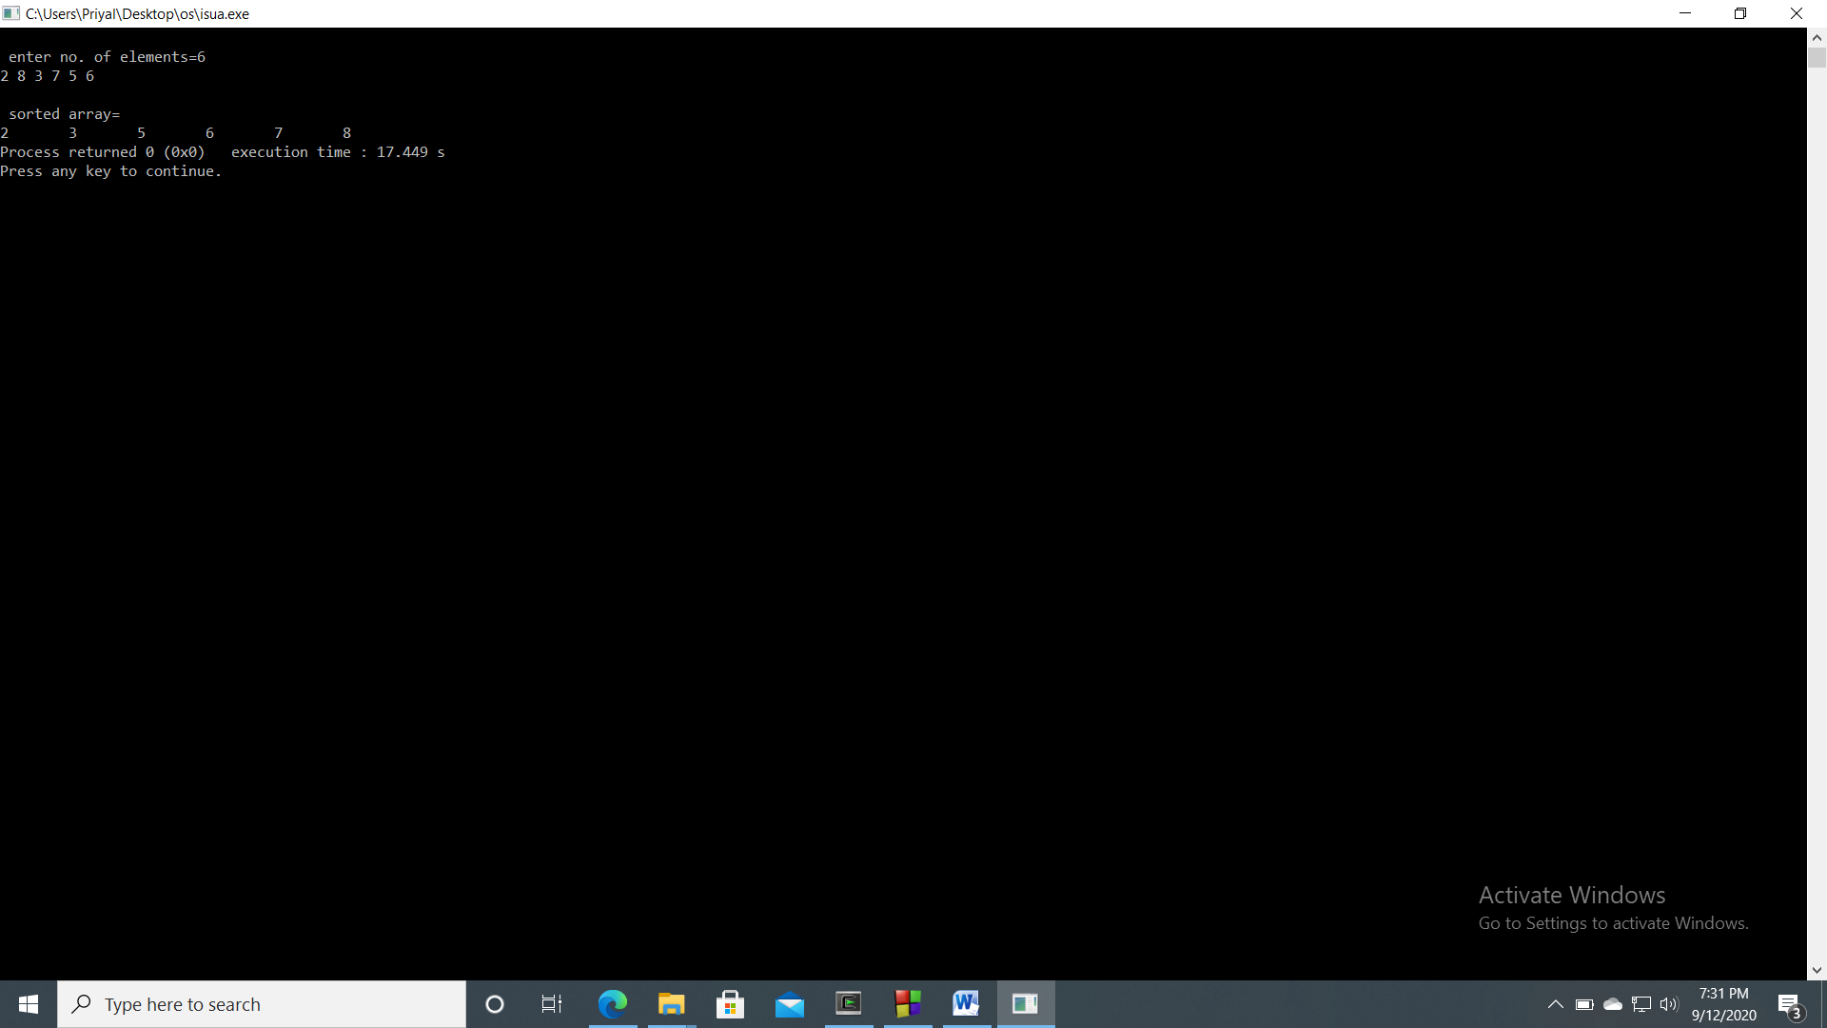

**(ii)Using recursion:-**

#include<stdio.h>

main()

{

int n,a[20],i;

printf("\n no. of elements=");

scanf("%d",&n);

printf("\n enter elements=\n");

for(i=0;i<n;i++)

{

scanf("%d",&a[i]);

}

insort(a,n);

printf("\n sorted array=\n");

for(i=0;i<n;i++)

{

printf("%d\t",a[i]);

}

}

void insort(int a[],int n)

{

int x,y;

if(n<=1)

{

return;

}

insort(a,n-1);

x=a[n-1];

y=n-2;

while(y>=0 && a[y]>x)

{

a[y+1]=a[y];

y--;

}

a[y+1]=x;}

**Output:-**

